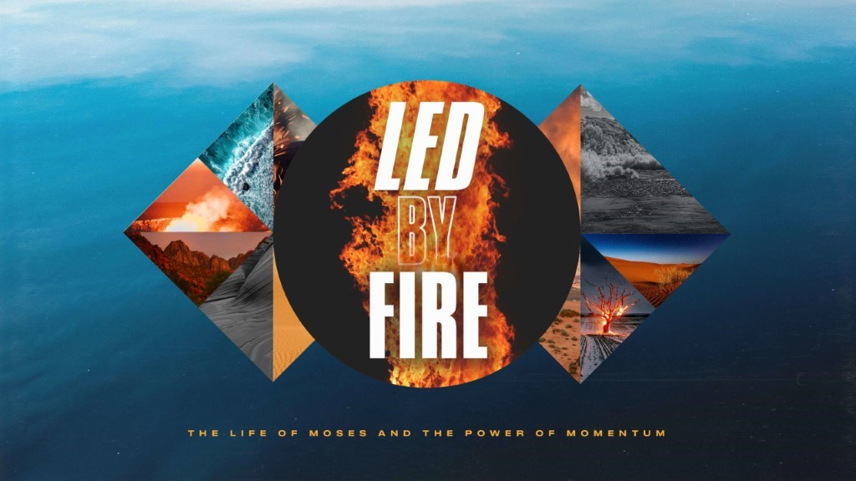

- James River Christmas was amazing! 265 people made decisions for Christ this past weekend, and many were blessed with financial aid, new furniture, and vehicles because of your generosity in Season of Giving! THANK YOU for being a part of what God is doing during this season.
- Life Groups can meet in person, and we would ask that you limit your gatherings to 25 (adults and children).
- Social Distancing and Care: Please continue to practice social distancing when meeting in person.

This Week’s Icebreaker Question:
What is your favorite holiday movie? Does your family have a Christmas movie tradition?
Sermon Specific Questions:
- Pastor Jeremy Foster spoke about finding hope in hard places. He stated that you cannot find hope in hard places unless you are honest about where you are. This can mean being honest with yourself but also with others. What are some challenges that you have been facing this season or difficulties that the Christmas season tends to bring for you? Why can it be difficult to admit when you are losing hope or having a hard time?

- Matthew 20 recounts a story of two blind men who called out to Jesus. Even though it was obvious what they needed, Jesus asked them “What do you want me to do for you?” Why did Jesus ask them what they wanted? Earlier in Matthew 7, Jesus told His disciples "Ask and it will be given to you; seek and you will find; knock and the door will be opened to you.” Making requests not only forces us to admit our need but also recognizes God’s ability to provide for us. Why is it easier to ask God for some things and harder for others? What encouragement would you offer to someone who has lost hope that God will help them?

- In Genesis 28 we read the story of Jacob on his journey to meet his brother Esau, after decades of separation. Jacob hadn’t left his family on good terms and was worried his brother still hated him and wanted him dead. Verse 11 says “When he reached a certain place, he stopped for the night because the sun had set. Taking one of the stones there, he put it under his head and lay down to sleep.” The rock that he slept with represented the problem he was facing and the fear of what was to come. Sometimes we can get comfortable with our problems or accept our despair. What happens when you “rest with your rock?”

- During the night, Jacob had a powerful encounter with God and asked God to bless him. “When Jacob awoke from his sleep, he thought, “Surely the Lord is in this place, and I was not aware of it.” He was afraid and said, “How awesome is this place! This is none other than the house of God; this is the gate of heaven.” Early the next morning Jacob took the stone he had placed under his head and set it up as a pillar and poured oil on top of it.” Jacob took his problem and made it a pillar to remember that God was with him and answered him during his struggle. How can we make pillars out of our problems? How do we choose to worship when we feel like weeping? Our goal can be to let problems refine us rather than define us.

