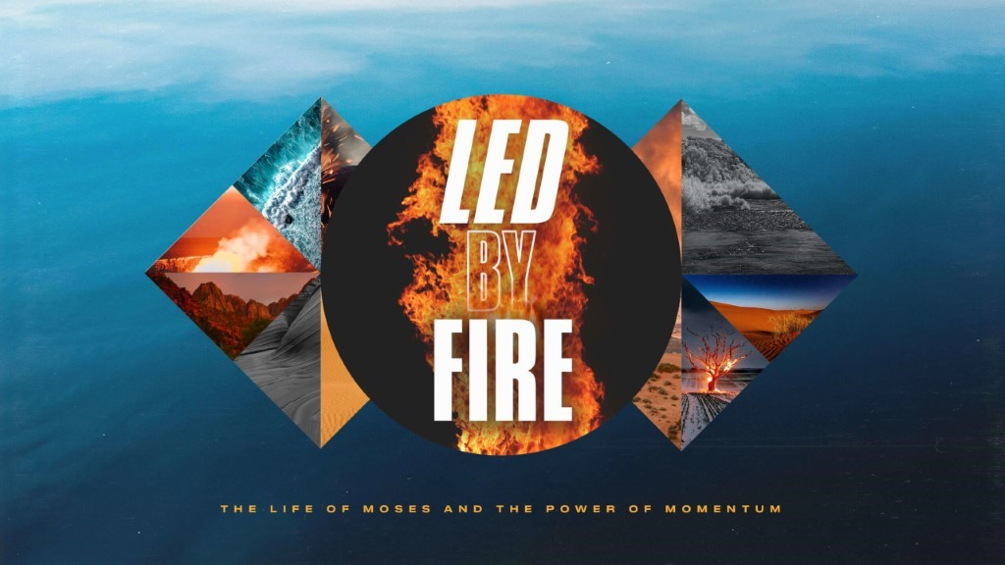

- The October 31st Party was amazing! Over 21,000 people drove through and experienced the joy and love of Christ through costume characters, giveaways, and lots of candy! A huge thank you to everyone who served and helped to make the afternoon possible.
- Life Groups can meet in person, and we would ask that you limit your gatherings to 25 (adults and children).
- Social Distancing and Care: Please continue to practice social distancing when meeting in person. We are not requiring that masks be worn but recommend a mask for those who prefer to wear one. And we encourage all those who are 65 years or older to continue to meet virtually. As a leader, based on these guidelines, you can decide what is best for the people in your group.
This Week’s Icebreaker Question:
What sport would you compete in if you were in the Olympics? If you could add an event to the Olympics what would it be?
Sermon Specific Questions:
- After the Israelites crossed through the Red Sea and the waters swept over the Egyptian army, Moses stopped them on the bank and they sang the first song ever recorded in scripture. It begins “I will sing to the LORD, for He has triumphed gloriously; the horse and his rider He has thrown into the sea. The LORD is my strength and my song, and He has become my salvation; this is my God, and I will praise him, my father’s God, and I will exalt him” (Ex. 15:1-2). “The song of Moses,” as it is called, is all about who God is. Worship centers on who God is. What insight do we receive about God from the first lines of Moses’ song? How can you incorporate a deeper understanding of God this week into your worship?

- Worship is based on the facts of what God has done for us, not our feelings in the moment. Worship consistently remembers and celebrates what God has done. Psalm 9:1 says “I will give thanks to the Lord with my whole heart; I will recount all of your wonderful deeds.” What are some of the wonderful deeds of the Lord in your life you can recount? What have you seen God do in 2020 so far that you can stop and praise Him for?

- In Exodus 15:12-16 the Israelites were declaring a future where their enemies would “tremble and quake at the power displayed by their God,” even though no one else knew what had happened yet. Pastor David’s third point on Sunday was that worship connects us to the future God has for us. What does this mean? How does our worship and the songs that we sing as a church play a prophetic role in our lives?

