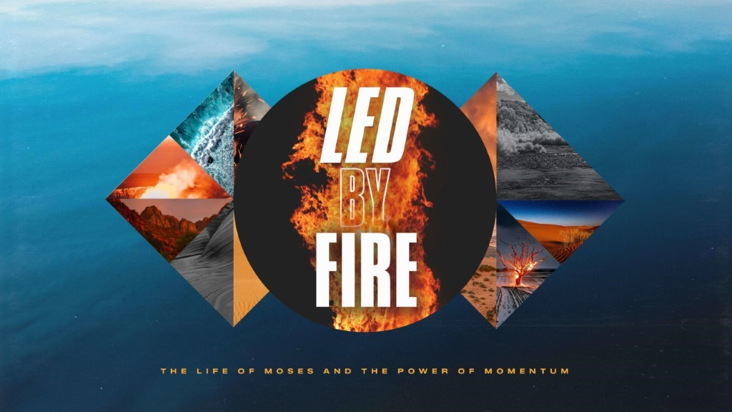

- A James River Christmas is just two weeks away! Pick up a stack of invitation cards at any campus and be sure to invite everyone you know, no one will want to miss it! Also, with additional service times, there are more opportunities to be a part of what God is doing. If you can serve an additional service on Saturday or Sunday, please let your Dream Team leader know!
- Life Groups can meet in person, and we would ask that you limit your gatherings to 25 (adults and children).
- Social Distancing and Care: Please continue to practice social distancing when meeting in person

This Week’s Icebreaker Question:
What is your favorite way to use Thanksgiving leftovers? Do you prefer traditional Thanksgiving food, like mashed potatoes, green beans, and stuffing, or would you rather have something else like pizza, stir fry, or a taco bar?
Sermon Specific Questions:
- In Exodus 17, we are introduced to a people called the Amalakites. The Amalakites were descendants from Esau, the brother of Jacob whom God renamed Israel. There was conflict between Jacob and Esau from the moment they were born, and conflict between the Amalakites and Israel from the beginning of their wilderness journey. The Amalakites would continue to plague the people of Israel for hundreds of years and became the representation of the worst kind of evil: satan, whose goal is the destruction of the people of God. Deuteronomy 25:18 tells us that the Israel was “weary and worn out,” when the Amalakites attacked them and they targeted “all who were lagging behind.” What insight does this give us concerning the strategy of the devil? What could “lagging behind” look like for us?

- God provides many weapons to use in warfare against the enemy, like prayer and fasting, but in Exodus 17, the battle was won by Moses lifting his hands to the Lord. “As long as Moses held up his hands, the Israelites were winning, but whenever he lowered his hands, the Amalekites were winning” (Ex. 17:11). Raised hands are part of Biblical prayer and worship from the Old Testament to the New Testament. (Leader suggestion, read: 1 Kings 8:22-23, Nehemiah 8:6, Lamentations 3:41-42, Psalm 28:2, and 1 Timothy 2:8) From these verses, what are some of these benefits of lifted hands?

- Even though the best Israelite soldiers were fighting, and the Lord was on their side, the battle was not a military struggle, but a spiritual one. On Sunday, Pastor John explained in all of life there is a spiritual component to the problems and challenges we face. What is the danger of ignoring a spiritual battle? What are some battles that you have faced or are facing that seemed physical but were spiritual?

- “When Moses' hands grew tired, they took a stone and put it under him and he sat on it. Aaron and Hur held his hands up- one on one side, one on the other- so that his hands remained steady till sunset.” Exodus 17:12 tells us that Moses was not alone but had friends with him. What are some examples of Biblical community and why are they so important?

