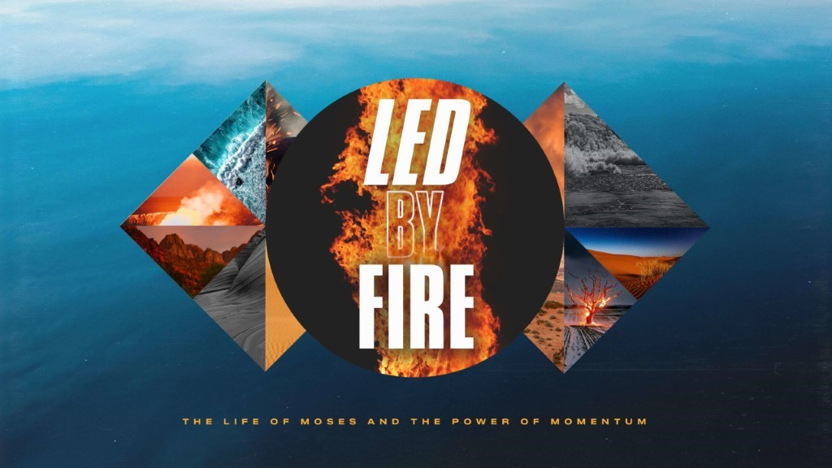

- We are so excited to announce the upcoming marriage conference with Mark and Grace Driscoll the weekend of February 12 and 13th. Register online today for the South Campus, Joplin Campus, or Online Experience.
- Life Groups can meet in person, and we would ask that you limit your gatherings to 25 (adults and children).
- Social Distancing and Care: Please continue to practice social distancing when meeting in person.

This Week’s Icebreaker Question:
If you had to spend the next six months in a different country, what country would it be and why would you choose that country?
Sermon Specific Questions:
In Exodus 19, the Israelites reach the Desert of Sinai and camp in front of Mount Sinai (otherwise known as Mount Horeb). God meets with Moses at the top of the mountain and reveals His presence and power to the people through thunder and lighting, fire and smoke, an earthquake, and a loud trumpet blast. In the next chapter, God would give His people the Ten Commandments and this would be the beginning of His covenantal relationship with them based on the Law. Before God showed up at the mountain in front of the people however, He told them to take three days to purify and consecrate themselves, so that they would be ready to be near His presence and accept His commands.
- In this coming new year, the most important thing any of us could do is to meet with God and walk with Him. What were Pastor John’s three suggestions for getting ready for 2021? (1. Recognize how much God loves us, 2. Respond in obedience, and 3. Set aside special time to be with God.) What will getting ready for 2021 look like for you?

- Recognizing how much God loves you can change your outlook on life, how you view yourself, and how you view others. What are the implications of not truly believing God loves you? What happens when God’s love becomes real in your life?

- “The Best is Yet to Come” is a phrase that is often repeated at the end of trying seasons. How can we be sure that the best is yet to come? What could hinder us from experiencing our best life as God intends it in this coming year? Pastor encouraged us to spend some time in fasting and prayer over this next month into the New Year, where and how can you apply this to your own life?

