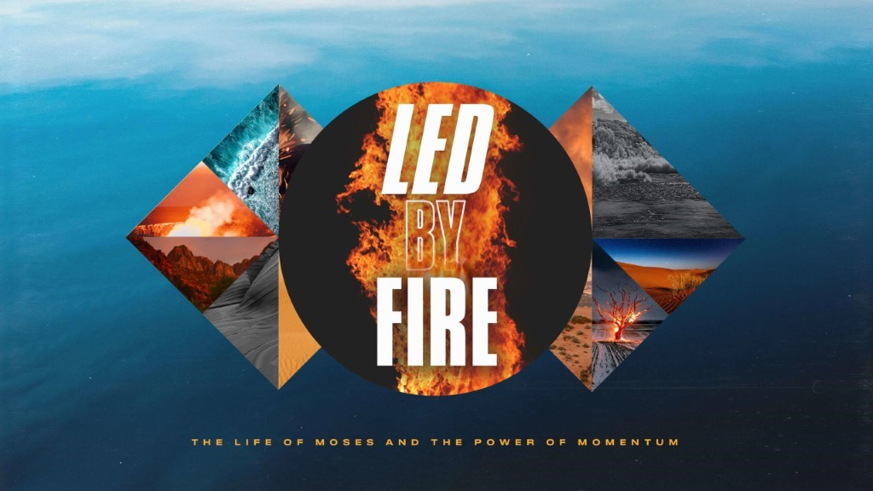

- A James River Christmas is now less than a month away! Pick up a stack of invitation cards at any campus and be sure to invite everyone you know, no one will want to miss it!
- Life Groups can meet in person, and we would ask that you limit your gatherings to 25 (adults and children).
- Social Distancing and Care: Please continue to practice social distancing when meeting in person. We are not requiring that masks be worn but recommend a mask for those who prefer to wear one. And we encourage all those who are 65 years or older to continue to meet virtually. As a leader, based on these guidelines, you can decide what is best for the people in your group.
This Week’s Icebreaker Question:
Would you rather take an all-expenses paid trip to Antarctica or the Sahara Desert? If you were to be stranded in the wilderness, would you rather be stranded alone with some survival tools and supplies or stranded in a group of people with nothing?
Sermon Specific Questions:

- On Sunday, Pastor Brandon preached from Exodus 15 when the nation of Israel was traveling through the wilderness and God led them to an Oasis called Elim. For many of us, the past year has been a season of uncertainty, intensity, limited resources, and fatigue- all parts of wilderness journey. Which aspect of a wilderness journey do you most relate to?

- We are not to be left in the wilderness forever, but God will lead us to places of refreshing just like David writes in Psalm 23, “The Lord is my shepherd, I lack nothing. He makes me lie down in green pastures, he leads me beside quiet waters, he refreshes my soul.” What refreshes your soul? God provides places of refreshment like our homes, church, His Word, and even Life Groups! Do you feel that you have made the most use out of the places of refreshment God has provided? How could you take more advantage of them?

- Sometimes rest and refreshment has to be cultivated. This can be done by setting apart time and places like church or Life Group as holy, times to celebrate what God has done instead of dwelling on the wilderness around us. Just like the Israelites, we can lose sight of the bigger picture and the purpose God has for us when we don’t stop and set up camp at places of refreshment. How can we stay focused on the big picture of what God is doing and where He is leading us?

